INSERT INTO Arts (ArtName, Type, FinishedYear)

VALUES ('Sandra', 'Minimalism', 1306),

('Sandra', 'Minimalism', 1340),

('Sandra', 'Art Deco', 1200),

('Sandra', 'CoBrA', 1400),

('Sandra', 'Street Art', 1930),

('Sandra', 'Pop Art', 1995),

('Sandra', 'Land Art', 2001),

('Sandra', 'Impressionism', 1703),

('Sandra', 'OP Art', 2006),

('Sandra', 'Bauhaus', 2001)

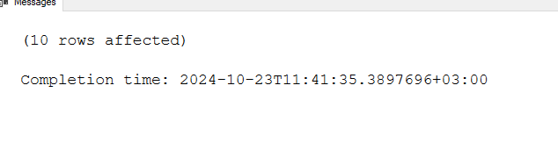

INSERT INTO Artists (FirstName, LastName, birthDate, info)

VALUES ('Sandra', 'Saar', 1306, ''),

('Sandra', 'Mark', 2006, ''),

('Sandra', 'LAst', 2001, ''),

('Sandra', 'Laar', 1999, ''),

('Sandra', 'li', 1998, ''),

('Sandra', 'hihi', 1300, ''),

('Sandra', 'muuah', 1267, ''),

('Maara', 'argh', 1306, ''),

('Saara', 'DUD', 1956, ''),

('Laura', 'Byfk', 2001, '')

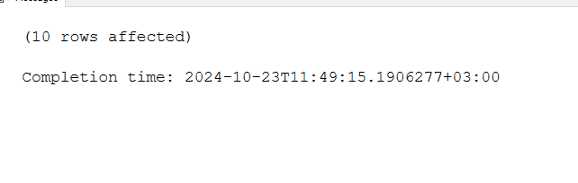

INSERT INTO Owners(FirstName, LastName, birthDate, info)

VALUES ('Maria', 'Saar', 2001, ''),

('Laura', 'Wa', 2000, ''),

('Maara', 'Sw', 2001, ''),

('Saara', 'SA', 1999, ''),

('Kaara', 'A', 1998, ''),

('Daara', 'S', 1978, ''),

('Laur', 'Di', 1987, ''),

('Kaur', 'Mi', 1980, ''),

('Taur', 'Ki', 1956, ''),

('jah', 'Li', 1999, '')

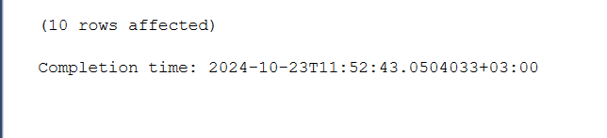

CREATE PROCEDURE Art

AS

Select ArtName, Type

FROM dbo.Arts

GO;

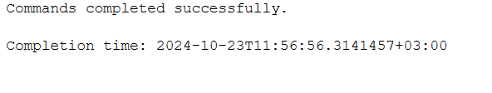

CREATE PROCEDURE Art

AS

Select ArtName, Type

FROM dbo.Arts

GO;

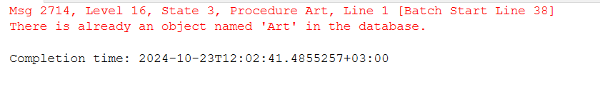

CREATE PROCEDURE Artist

AS

Select FirstName, LastName

FROM dbo.Artists

GO;

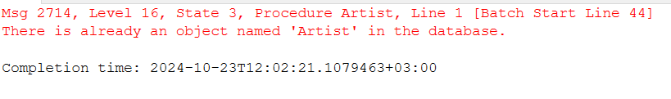

CREATE PROCEDURE Owner

AS

Select FirstName, LastName

FROM dbo.Owners

GO;

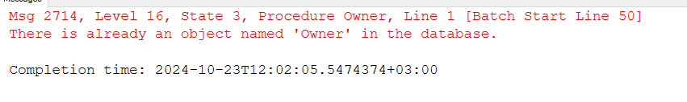

SELECT \* from dbo.Arts

full join dbo.Artists on dbo.Arts.ArtName = dbo.Artists.FirstName

